
Department of Computer Engineering and Technology
MINI PROJECT REPORT
Computer Networks Laboratory
(CSE20110)
Laboratory Continuous Assessment 3

LAN-Based Collaborative Whiteboard

Submitted by
Sr. No. | Student Name | PRN
1 | Vedant Pawaskar | 1262242102
2 | Prajakta Choughule | 1262241465
3 | Yashraj Agale | 1262242073
4 | Bhavya Maisuria | 1262243418

Group No. 18 Panel K Batch : 1 and 2
Third Year B.Tech. Computer Engineering and Technology
Under the guidance of
Dr. Uma Pujeri
Academic Year 2026–2027
Submission Date 22 October 2026
Department of Computer Engineering and Technology
CERTIFICATE

This is to certify that the mini-project entitled “LAN-Based Collaborative Whiteboard” has been carried out by the following students of Third Year B.Tech. Computer Science and Engineering, Panel k , Batch 1 and 2, Group No. 18, under my guidance during the academic year 2026–2027.
Student Name | PRN
Vedant Pawaskar | 1262242102
Prajakta Choughule | 1262241465
Yashraj Agale | 1262242073
Bhavya Maisuria | 1262243418

The report is submitted towards the mini-project component of Laboratory Continuous Assessment 3 for the Computer Networks Laboratory course.

Faculty Signature __________________________
Dr. Uma Pujeri
Project Guide and Course Faculty
Date ____________________ Place: Pune

Acknowledgement
We express our sincere gratitude to our faculty guide, Dr. Uma Pujeri, for the guidance, feedback and encouragement we received throughout this Computer Networks Laboratory mini-project.
We thank the Department of Computer Engineering and Technology, MIT World Peace University, Pune, for the laboratory facilities that allowed us to build and test the application. We also acknowledge the technical resources on which the work relied: the IETF specifications for TCP, HTTP and WebSocket, and the FastAPI, Uvicorn, MDN Web Docs and Python documentation listed in the references.
Group No. 18

Abstract
Shared drawing over a network usually depends on cloud tools. This mini-project builds a LAN-based collaborative whiteboard that lets several users on one local network draw on a single canvas using only a web browser. One computer runs a Python FastAPI server on Uvicorn; clients load the page over HTTP and then open a persistent WebSocket connection, carried over TCP on port 8000. Every draw, erase and clear action is sent as a small JSON message; the server stores it, broadcasts it to all connected clients and replays the stored drawing to any client that joins or reconnects.
The objectives were to apply local addressing, the client–server model, HTTP, WebSocket and TCP in a working system and to test it. All nine test cases, covering connection, drawing, erasing, clearing, late joining, disconnection, server restart and load, passed. On a loopback connection with up to twelve simultaneous clients, the mean delivery delay was 0.21 ms and all 500 events of a broadcast test reached each of nine receivers. The main limitations are in-memory state, no authentication or encryption, and tests that exclude real Wi-Fi delay. The prototype suits classroom demonstration of networking concepts.
Keywords: Computer Networks, LAN, Client–Server, HTTP, WebSocket, TCP/IP, JSON, FastAPI, Real-time Collaboration.

Table of Contents
Acknowledgement 3
Abstract 4
1 Introduction and Project Objectives 7
1.1 Introduction and Background 7
1.2 Problem Statement 8
1.3 Scope 8
1.4 Objectives 9
2 Proposed Design and Requirements 10
2.1 Architecture and Network Topology 10
2.2 Tools and System Requirements 11
2.3 Addressing and Protocol Selection 11
3 Implementation and Technical Working 14
3.1 Methodology 14
3.2 Configuration or Code Implementation 15
3.3 Protocols and Technical Working 16
3.4 Execution Procedure 18
4 Testing and Results 19
4.1 Test Plan 19
4.2 Results and Execution Evidence 20
4.3 Objective Achievement 22
5 Discussion and Conclusion 23
5.1 Discussion and Comparative Analysis 23
5.2 Advantages and Applications 23
5.3 Limitations 24
5.4 Challenges and Troubleshooting 25
5.5 Future Scope 25
5.6 Conclusion 26
References 27
AI Usage Declaration 28
Appendices 29
Appendix A Code and Configuration 29
Appendix B Additional Evidence 30
Appendix C Individual Contributions 30

List of Figures
Figure 2.1 System architecture of the LAN-based collaborative whiteboard 10
Figure 3.1 Message sequence between two clients and the server 14
Figure 3.2 Server console output (Uvicorn started; HTTP requests followed by WebSocket connections) 18
Figure 4.1 Whiteboard open in the host browser (connected, one user) 20
Figure 4.2 Three clients connected to the same session (“Users Online: 3”) 20
Figure 4.3 Drawing as seen by Client A 20
Figure 4.4 The same drawing on Client C 20
Figure 4.5 Erase by Client B is reflected on Client A 21
Figure 4.6 A late joiner receives the existing drawing 21
Figure 4.7 After one client closes, the count returns to 3 21
Figure 4.8 After CLEAR every canvas is empty 21

List of Tables
Table 1.1 Objectives and verification methods 9
Table 2.1 Architecture components and responsibilities 10
Table 2.2 Tools and system requirements 11
Table 2.3 Addressing and ports 12
Table 2.4 Protocol stack view 12
Table 2.5 Main event types 13
Table 4.1 Test cases and observed results 19
Table 4.2 Performance measurements (loopback, n = 200 unless stated) 22
Table 4.3 Objective achievement 22
Table 5.1 Design choices compared with alternatives 23
Table 5.2 Challenges and troubleshooting 25
Table A.1 Project files and modules 29
Table B.1 Mapping of the syllabus to the project 30
Table C.1 Individual contributions 30

1 Introduction and Project Objectives

1.1 Introduction and Background
Computer networks allow devices to exchange information using agreed protocols. A local area network (LAN) connects devices within a limited area such as a laboratory, classroom, office or home. Applications built on a LAN can share resources and services without depending on the public Internet, which makes a LAN a convenient environment for studying how protocols behave.
A collaborative whiteboard is a good example because the user action is visual, yet the application must transmit that action as data. The network does not carry a screenshot of the screen; it carries compact messages (coordinates, colour and brush width) that each browser turns back into a drawing. This shows clearly how an application-layer protocol is layered on top of TCP/IP.

1.1.1 Local Area Network (LAN)
A LAN connects devices through a Wi-Fi access point or an Ethernet switch, forming a star topology. In this project the host computer and all client devices must be on the same LAN so that clients can reach the host directly. A shared Wi-Fi name alone does not guarantee communication: guest Wi-Fi, client (AP) isolation, firewall rules or institutional policies may block device-to-host traffic.

1.1.2 IP Addressing and Ports
An IP address identifies a network interface at the network layer; on a home or campus LAN it is usually a private IPv4 address such as 192.168.x.x. A port identifies the application endpoint on a host: the IP address selects the machine and the port selects the program. The server listens on TCP port 8000, and clients reach it at http://<HOST-LAN-IP>:8000.

1.1.3 Client–Server Architecture
The server is the central coordinator. Each browser is a client that sends user actions and receives events produced by other clients. Because every client talks only to the server, no client needs to discover or connect to any other client. The trade-off is that the server becomes a single point of failure for live collaboration.

1.1.4 TCP and Reliability
TCP provides a reliable, ordered byte stream between two endpoints for as long as the connection stays open: lost segments are retransmitted and data is delivered in order [1]. TCP does not know that a JSON message means “draw a line”; the application defines message boundaries and meaning. If the connection breaks, the application must detect it and recover, which this project does with an automatic reconnect in the client.

1.1.5 HTTP and WebSocket
HTTP is the request–response protocol used when a browser asks for the page and its files [2]. WebSocket starts with an HTTP-based opening handshake (an Upgrade request answered with 101 Switching Protocols) and then keeps the same TCP connection open for messages in both directions [3]. This avoids repeatedly polling the server and lets the server push an update at the moment it happens. The client chooses ws:// or wss:// automatically, depending on whether the page was loaded over http or https.

1.1.6 Review of Relevant Sources
The FastAPI documentation [4] describes how a WebSocket endpoint is declared and how messages are received and sent, and Uvicorn [5] is the ASGI server that runs the application and listens on the chosen host and port. The MDN references for the browser WebSocket API [6] and the Canvas API [7] describe the client-side calls used to open the connection and to draw line segments. The Python socket programming HOWTO [8] gives the background on sockets, the endpoint abstraction on which TCP-based client–server programs are built. Appendix B relates these topics to the course syllabus.

1.2 Problem Statement
In a group discussion, students often need to explain diagrams, algorithms, network topologies or calculations together. A physical board is not always available, and sending separate screenshots does not give a shared, live view. The project therefore creates a shared canvas that works across any device on the same LAN, using nothing more than a browser on the client side.

1.3 Scope
The system is intended for students and laboratory or classroom groups working together on one local network. The scope and boundaries are:
- Covered: freehand drawing, erasing and clearing on a shared canvas; a live count of users online; late joiners and reconnecting clients receive the current drawing.
- Network: a single trusted LAN (Wi-Fi access point or Ethernet switch) with one host computer running the server and any number of browser clients.
- Assumptions: all devices are on the same network with no client isolation, the chosen TCP port is allowed by the host firewall, and clients use a modern browser with HTML5 Canvas support.
- Not covered: user accounts, encryption, persistent storage and deployment on the public Internet.

1.4 Objectives
The aim is to develop a browser-based whiteboard that demonstrates core Computer Networks concepts in a working multi-user system. Each objective below can be checked through implementation and testing; the test identifiers refer to Table 4.1.
Table 1.1 Objectives and verification methods
Objective ID | Objective | Verification Method
O1 | Develop a browser-based whiteboard accessible to multiple devices on a local network. | T1, T2: page loads and several clients connect
O2 | Use a central server that receives drawing events and broadcasts them to every connected client. | T3, T4, T5: strokes, erase and clear seen on all clients
O3 | Apply HTTP for delivering the page and WebSocket for two-way, low-latency live updates. | T1 (HTTP 200), T2–T3 (live WebSocket updates), delay measurements
O4 | Represent actions as structured JSON messages (DRAW, ERASE, CLEAR, SYNC, etc.) and process them consistently. | T3–T6: identical drawing on all canvases
O5 | Support joining, leaving and re-joining clients, with the current drawing replayed to every new client. | T6, T7, T8: late join, disconnect and restart
O6 | Test connection, drawing, erasing, clearing, joining, disconnection and multi-client load, and relate the results to Computer Networks theory. | T1–T9 and the performance measurements in Section 4.2

2 Proposed Design and Requirements

2.1 Architecture and Network Topology
The system follows a client–server model on a star-topology LAN. The host computer runs the FastAPI application under Uvicorn. Browser clients on other devices (and on the host itself) load the page over HTTP and then keep a WebSocket connection to the /ws endpoint. The server keeps the list of connected clients and the list of drawing operations in memory, which it uses for broadcasting and for synchronising late joiners. Figure 2.1 shows the components and Table 2.1 lists their responsibilities.
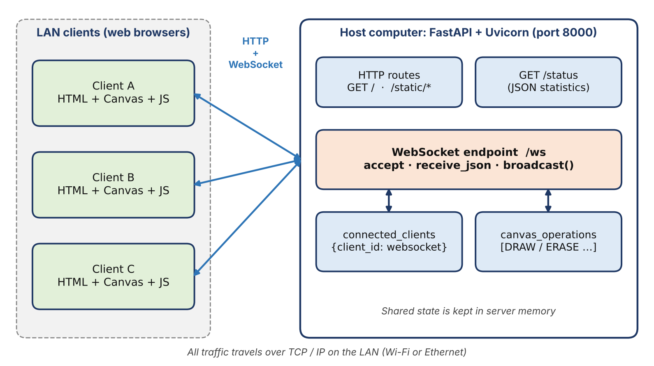
Figure 2.1 System architecture of the LAN-based collaborative whiteboard
Table 2.1 Architecture components and responsibilities
Component | Technology / role | Responsibility
Client browser | HTML, CSS, JavaScript, Canvas | Shows the drawing area and toolbar; captures pointer movement; sends events; renders received events
HTTP application | FastAPI / Uvicorn | Serves index.html and static assets (/static) and the /status information endpoint over HTTP
WebSocket endpoint | /ws | Accepts persistent client connections, receives events and broadcasts them
Connection manager | connected_clients dictionary | Maps each client_id to its WebSocket; used for broadcasting and counting users online
Drawing state | canvas_operations list (in memory) | Stores DRAW/ERASE operations so that a joining client can be synchronised; emptied by CLEAR

2.1.1 Why Use a Central Server?
With N clients, direct peer-to-peer sharing would require every client to discover and maintain connections to the other N−1 clients (up to N(N−1)/2 connections in total) and to handle NAT or firewall issues for each. A central server needs only N connections, keeps the shared drawing for late joiners in one place and keeps the client code simple. Its drawbacks are that it is a single point of failure and a possible bottleneck for very large groups.

2.2 Tools and System Requirements
Table 2.2 lists the software, hardware and network resources used. The implementation files are listed in reference [9].
Table 2.2 Tools and system requirements
Tool or Resource | Version or Specification | Purpose
Host computer | Windows, macOS or Linux with Python 3 (tested with Python 3.13) | Runs the server and, optionally, a browser client
FastAPI [4] | As pinned in requirements.txt [9] | HTTP routes and the WebSocket endpoint
Uvicorn [5] | uvicorn[standard], as in requirements.txt | ASGI server listening on 0.0.0.0, TCP port 8000
Client devices | Computers, tablets or phones with a modern browser (Chromium used in testing) | Run the whiteboard page and draw on the shared canvas
Frontend | HTML5, CSS, JavaScript; Canvas API [7] and WebSocket API [6] | User interface, pointer capture, rendering and messaging
Network | Shared Wi-Fi or wired LAN without client isolation; TCP port 8000 allowed | Carries HTTP and WebSocket traffic between clients and host
Start scripts | START_WINDOWS.bat, START_MAC_LINUX.sh | Create a virtual environment, install requirements and start the server

2.3 Addressing and Protocol Selection

2.3.1 Addressing
This is a socket-based application rather than a device-configuration project, so the addressing table lists the host and client endpoints. The server is started with the options --host 0.0.0.0 --port 8000, which means it listens on all available IPv4 interfaces of the host on TCP port 8000. The address 0.0.0.0 is only a bind address and is not what clients type: clients use the host’s actual LAN IP address (found with ipconfig on Windows or ipconfig getifaddr en0 on macOS). The address may change if the computer joins another network or receives a new DHCP lease.
Table 2.3 Addressing and ports
Device / Interface | IP / Prefix | Gateway | Role
Host computer (server) | Private LAN IPv4, e.g. 192.168.x.x; bind address 0.0.0.0; TCP port 8000 | LAN router / access point (not configured by the project) | Serves the page over HTTP and accepts WebSocket connections at /ws
Client devices | Private LAN IPv4 from DHCP, same subnet as the host; ephemeral source port | LAN router / access point | Open http://<HOST-LAN-IP>:8000 in a browser
Host loopback (testing) | 127.0.0.1 / localhost, port 8000 | Not applicable | Used for local access and for the measurements in Chapter 4

2.3.2 Protocol Stack and Choice of Protocols
HTTP delivers the page and its files. For the live drawing channel, WebSocket was chosen instead of repeated HTTP polling: it starts with an HTTP handshake and then keeps one TCP connection open for messages in both directions, so the server can push an update the moment it happens, without a new request and a full set of HTTP headers for every update. TCP gives reliable, ordered delivery, so every JSON message arrives complete and strokes are drawn in the sequence they were made. Table 2.4 shows how the layers are used.
Table 2.4 Protocol stack view
Layer / concept | Role in this project | Example
Application | Defines drawing commands and synchronisation messages (JSON) | DRAW, ERASE, CLEAR, SYNC, WELCOME
WebSocket / HTTP | HTTP serves the page; WebSocket carries bidirectional application messages | GET / ; persistent /ws connection
TCP | Reliable, ordered transport while the connection remains open | Browser ↔ host, destination port 8000
IP | Routes packets between network interfaces on the LAN | Host LAN IP and client IP addresses
Link / Wi-Fi or Ethernet | Moves frames across the local network | Access point / switch and the wireless or wired link

2.3.3 Message Format and Event Types
JSON is easy to produce and parse in both JavaScript (browser) and Python (server). The DRAW message below is sent while the user drags the pointer: x and y are the current canvas coordinates and prev_x, prev_y the previous ones, so the receiver can draw a line segment. The server copies these fields into its own record, adds a timestamp and broadcasts it. Table 2.5 lists the event types.
{
"type": "DRAW",
"user_id": "a3f9c1d2",
"x": 125, "y": 210,
"prev_x": 118, "prev_y": 203,
"color": "#111111",
"width": 4
}

Table 2.5 Main event types
Event | Direction and meaning | Behaviour
DRAW | Client → server → all clients. One line segment was drawn. | Server stores it in canvas_operations and broadcasts; clients draw the segment with the received colour and width.
ERASE | Client → server → all clients. One erased segment. | Stored and broadcast; clients paint the segment in white with a wider stroke (4 × brush size).
CLEAR | Client → server → all clients. Board cleared. | Server empties canvas_operations; every client clears its canvas.
SYNC | Server → joining client. All stored operations. | Client clears its canvas and replays every operation in order.
WELCOME | Server → joining client. client_id and users_online. | Client stores its user id and shows the number of users online.
USER_JOINED / USER_LEFT | Server → other clients. A client connected or disconnected. | Clients update the “Users Online” counter and show a status message.
PING / PONG | Client → server → client. Latency probe. | Server replies PONG carrying both timestamps; used to measure round-trip time.

2.3.4 Message Delivery and Ordering
TCP preserves byte order on an established connection and WebSocket defines message framing on top of it, so each JSON message arrives complete and in the order sent by one client. Events from different users are applied in the order in which the server processes them, so strict global ordering is not enforced; overlapping strokes from different users may appear in slightly different order on different screens, which is visually negligible.

3 Implementation and Technical Working

3.1 Methodology
The application was implemented in the following sequence, moving from the shared protocol to the server, then the client, and finally testing:
- Define the JSON message types and fields (Section 2.3.3) that both server and client use.
- Create the FastAPI application, serve the page and static files over HTTP, and add the /status information endpoint.
- Add the /ws WebSocket endpoint with a registry of connected clients (connected_clients) and a list of stored drawing operations (canvas_operations).
- Implement broadcasting, the SYNC and WELCOME messages for joining clients, and USER_JOINED / USER_LEFT notifications.
- Build the client: canvas, toolbar, pointer capture, JSON event creation, rendering of received events and automatic reconnection.
- Write the start scripts and test the system with multiple clients (Chapter 4).
Figure 3.1 shows the resulting message flow between two clients and the server.
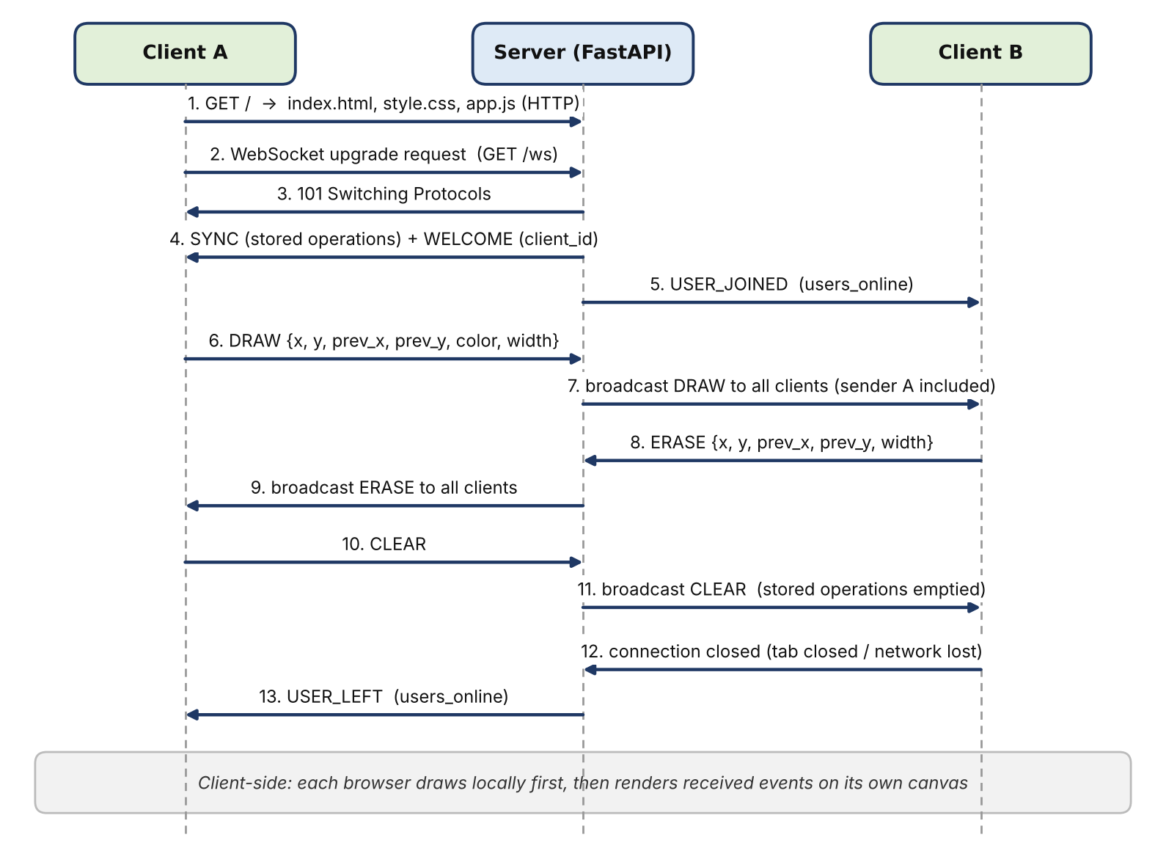
Figure 3.1 Message sequence between two clients and the server

3.2 Configuration or Code Implementation
The project consists of a server module (main.py), a requirements file and three client files (index.html, style.css, app.js) [9]. The key responsibilities of each side are summarised below.

3.2.1 Server Responsibilities (main.py)
The server starts the FastAPI application and exposes GET / (the web page), /static (CSS and JavaScript) and GET /status. It accepts WebSocket clients at /ws, gives each a short client_id, and maintains the connected_clients dictionary and the canvas_operations list. It interprets the event types DRAW, ERASE, CLEAR and PING, broadcasts DRAW, ERASE and CLEAR events and the USER_JOINED / USER_LEFT notices, and sends SYNC (the stored drawing) and WELCOME to each joining client. On a disconnect or connection error it removes the client and notifies the others, so dead connections are not used again.

3.2.2 Client Responsibilities (app.js)
The client loads the page and its files over HTTP, opens a WebSocket connection to ws://<host>/ws (wss:// when the page uses https) and reconnects automatically every 2 seconds if the connection is lost. It converts pointer movement into line segments with colour, brush size and tool (draw or eraser), serialises each segment as a JSON message and sends it only when the socket is open. It renders incoming events, updates the connection status and user count, and handles CLEAR and SYNC by clearing the canvas and replaying the stored operations.

3.2.3 Broadcast Loop
The following simplified excerpt shows how the server sends a message to every connected client and removes any client to which sending fails. The complete files are listed in Appendix A.
async def broadcast(message, exclude=None):
for client_id, ws in list(connected_clients.items()):
if client_id == exclude:
continue
try:
await ws.send_json(message)
except Exception:
connected_clients.pop(client_id, None)

3.3 Protocols and Technical Working

3.3.1 Typical User Flow
- The host computer starts the application server (Uvicorn) and listens on port 8000 on all interfaces.
- A client browser requests the home page through HTTP (GET /) and then downloads style.css and app.js.
- The browser’s script opens a WebSocket connection to ws://<host>:8000/ws.
- The server accepts the connection, assigns an 8-character client_id, and sends SYNC (the stored drawing) followed by WELCOME (client_id and users online); other clients receive USER_JOINED.
- When a user draws or erases, the browser draws locally and sends a DRAW or ERASE message containing the current and previous pointer coordinates.
- The server stores the operation and broadcasts it over WebSocket to the connected clients.
- Each browser renders the received operation on its own HTML canvas; CLEAR empties every canvas.
- When a client closes the page or loses connectivity, the server detects the closed connection, removes it from connected_clients and broadcasts USER_LEFT.

3.3.2 Server-Side Algorithm
- Create the FastAPI application, mount /static, and initialise connected_clients = {} and canvas_operations = [].
- When a WebSocket request arrives at /ws, accept the connection.
- Generate a client_id and register the WebSocket in connected_clients.
- Send SYNC with all stored operations, then WELCOME with the client_id and number of users online, to the new client; broadcast USER_JOINED to the others.
- Wait for a JSON message from the client (receive_json).
- Read the type field: DRAW and ERASE build an operation record with a timestamp; CLEAR empties the list; PING produces a PONG reply.
- Append DRAW/ERASE operations to canvas_operations so that later clients can be synchronised.
- Broadcast the operation (or CLEAR) to the connected clients; any client to which sending fails is removed.
- On WebSocket disconnect or any error, remove the client, broadcast USER_LEFT and end its handler.

3.3.3 Client-Side Algorithm
- Load the canvas, size it to its container and register pointer-down, pointer-move and pointer-up handlers.
- Connect to the WebSocket endpoint derived from window.location.
- On pointer movement with the button pressed, draw the segment locally and capture the previous and current coordinates with the selected colour and width.
- Create the DRAW (or ERASE) event and send it if the socket is open.
- On each message from the server, switch on its type: WELCOME stores the id, SYNC replays all operations, DRAW/ERASE render a segment, CLEAR clears the canvas, USER_JOINED/USER_LEFT update the counter.
- On close, show “Disconnected”, wait 2 seconds and reconnect; the new connection receives SYNC and so recovers the full drawing.

3.3.4 Why Broadcast Events Instead of Screenshots?
A drawing event of this form is only a few hundred bytes (about 130–200 bytes of JSON), whereas an image of the board would be many kilobytes after every pointer movement. Sending events also lets each browser render the board at its own resolution and lets the server replay the history to late joiners. The actual bandwidth still depends on how often events are sent, the number of connected clients and the message fields; batching or throttling pointer events would reduce it further.

3.3.5 Error and Disconnect Handling
A client may close its tab, change networks or lose Wi-Fi, and the server must not keep sending to a dead connection. In main.py, WebSocketDisconnect (and any other exception raised in the receive loop) removes the client from connected_clients and broadcasts USER_LEFT, and broadcast() additionally removes any client whose send fails. In testing, a malformed (non-JSON) message made the server end only that client’s connection while all other clients continued normally. If the server process stops, all connections close and the in-memory drawing is lost; the browser then retries every 2 seconds and works again once the server is restarted, with an empty board.

3.4 Execution Procedure
To run the project, the prerequisites are Python 3 on the host and a browser on each client. The steps are:
- Connect the host and client devices to the same network.
- On the host, run START_WINDOWS.bat (Windows) or START_MAC_LINUX.sh (macOS/Linux). The script creates a virtual environment, installs the requirements and runs uvicorn main:app --host 0.0.0.0 --port 8000.
- Find the host’s LAN IP address (ipconfig getifaddr en0 on macOS, ipconfig on Windows). Do not use 0.0.0.0 as the browser address.
- On each client, open a browser and enter http://<HOST-LAN-IP>:8000, then type a user name.
- Draw on one device and check that every other connected client shows the same drawing.
- Keep the server terminal open during the demonstration and stop it with Ctrl+C when finished.
Figure 3.2 shows the server console after start-up: Uvicorn is listening, HTTP requests for the page are followed by WebSocket connections, which confirms the HTTP-then-WebSocket sequence described in Section 3.3.
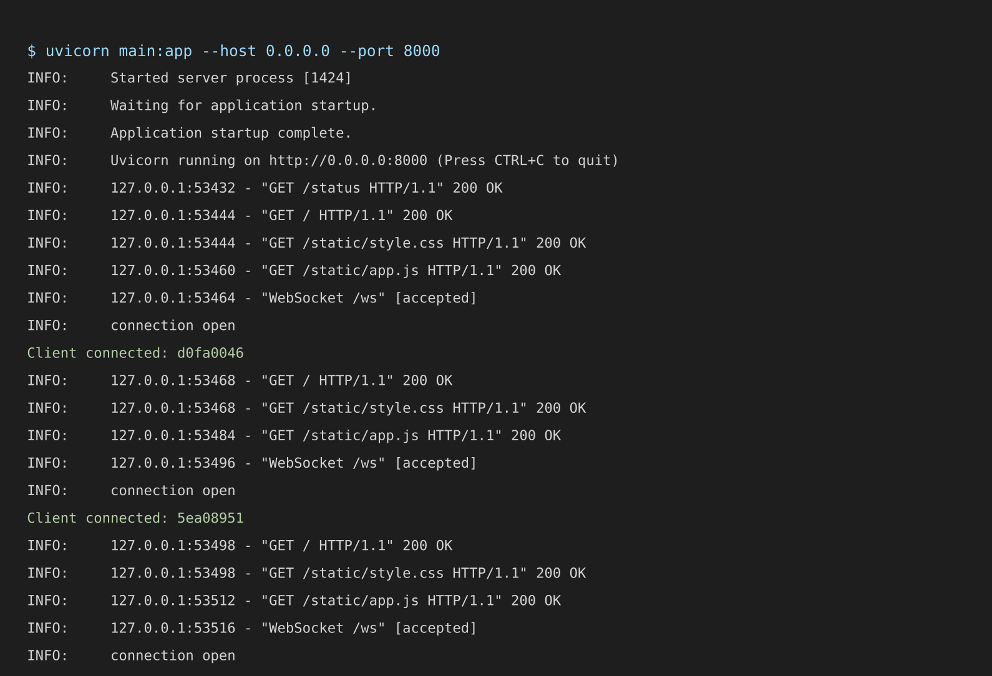
Figure 3.2 Server console output (Uvicorn started; HTTP requests followed by WebSocket connections)

4 Testing and Results

4.1 Test Plan
The unmodified project was started with uvicorn main:app --host 0.0.0.0 --port 8000 (Python 3.13, FastAPI, Uvicorn). Three to four Chromium clients were driven through real mouse input on the actual page, and a script using raw WebSocket connections measured latency and load. All clients ran on one machine over the loopback interface, so the results verify the application logic, protocol behaviour and server capacity but not Wi-Fi delay. A test passes when the observed behaviour matches the expected result.
Table 4.1 Test cases and observed results
Test ID | Test and Input | Expected Result | Observed Result | Status
T1 | Open the app from the host browser. | Home page loads successfully. | HTTP 200; status shows “Connected”. | Pass
T2 | Open the app from a second and third client. | Clients reach the server and connect. | 3 clients connected; “Users Online: 3” shown to all. | Pass
T3 | Draw from Client A. | Other connected clients show the stroke. | Identical drawn-pixel count (3,776) on all three canvases. | Pass
T4 | Use the eraser from one client. | Erase is reflected on the other clients. | Erase by Client B removed part of A’s stroke on every canvas. | Pass
T5 | Clear the shared board. | All connected canvases become clear. | All canvases empty (0 drawn pixels); server list emptied (0 operations). | Pass
T6 | Connect a new client after drawing exists. | New client receives the existing drawing. | Late joiner displayed all earlier strokes via SYNC. | Pass
T7 | Close one client. | Server detects the disconnect and continues. | Count dropped from 4 to 3; drawing continued. | Pass
T8 | Stop and restart the server. | Clients can connect only once the server is back; board is empty. | Server unreachable while stopped; after restart a new client received an empty SYNC. | Pass
T9 | Several clients drawing; load test. | Application remains usable with no lost events. | 12 clients; 500 events from one client delivered to all 9 measured receivers (500/500 each). | Pass

4.2 Results and Execution Evidence
Figures 4.1 and 4.2 show tests T1 and T2: the page loads in the host browser with the status “Connected”, and three clients joined the same session, each showing “Users Online: 3”. This proves that the HTTP page delivery and the WebSocket connections work and that the server tracks the membership.
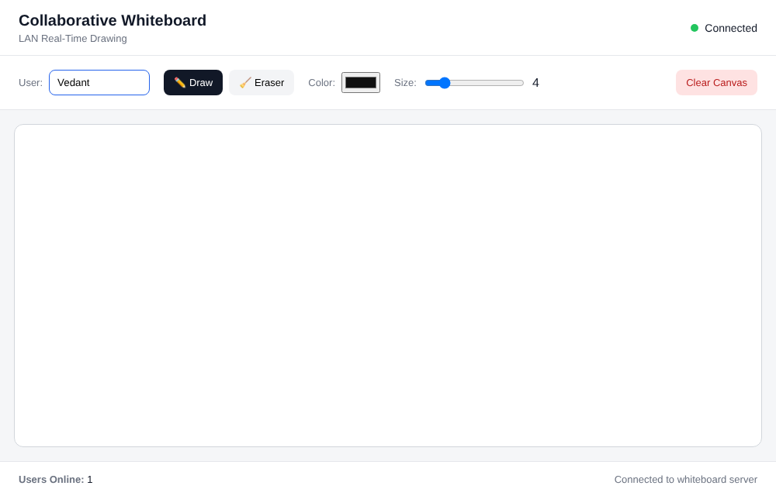  Figure 4.1 Whiteboard open in the host browser (connected, one user) | 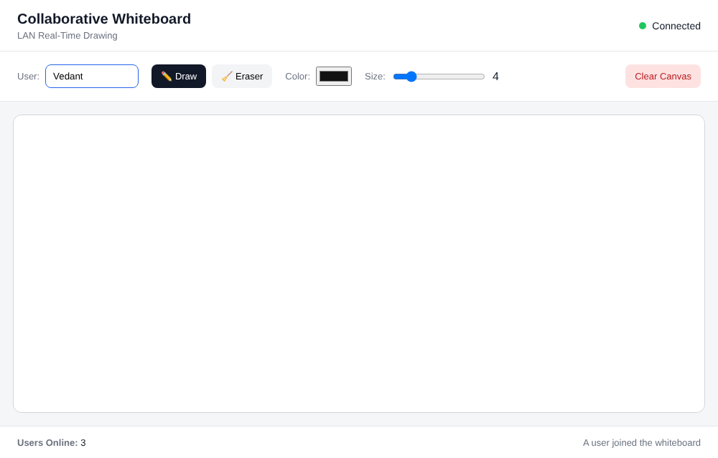  Figure 4.2 Three clients connected to the same session (“Users Online: 3”)

Figures 4.3 and 4.4 show test T3. The same drawing appears on Client A and Client C, and the drawn-pixel count (3,776) was identical on all three canvases, so the broadcast delivered every segment to every client.
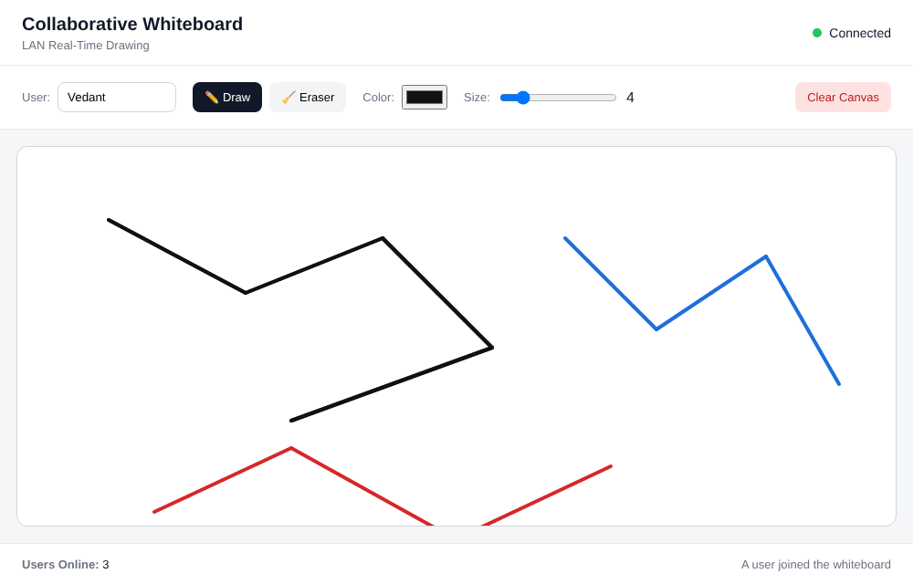  Figure 4.3 Drawing as seen by Client A | 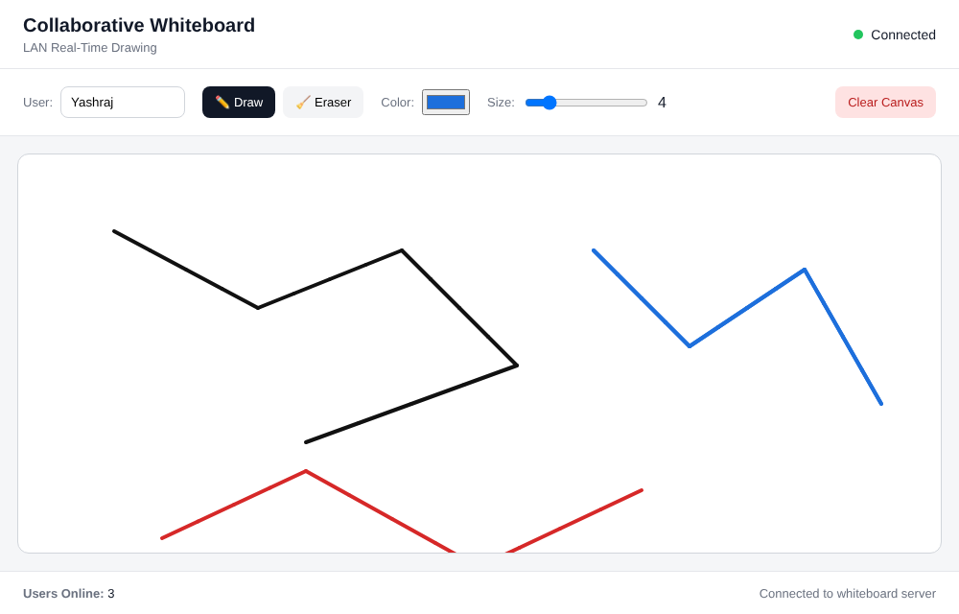  Figure 4.4 The same drawing on Client C

Figure 4.5 (test T4) shows that an erase made by Client B is reflected on Client A, so ERASE events are broadcast like DRAW events. Figure 4.6 (test T6) shows that a client that joins late receives the existing drawing through SYNC.
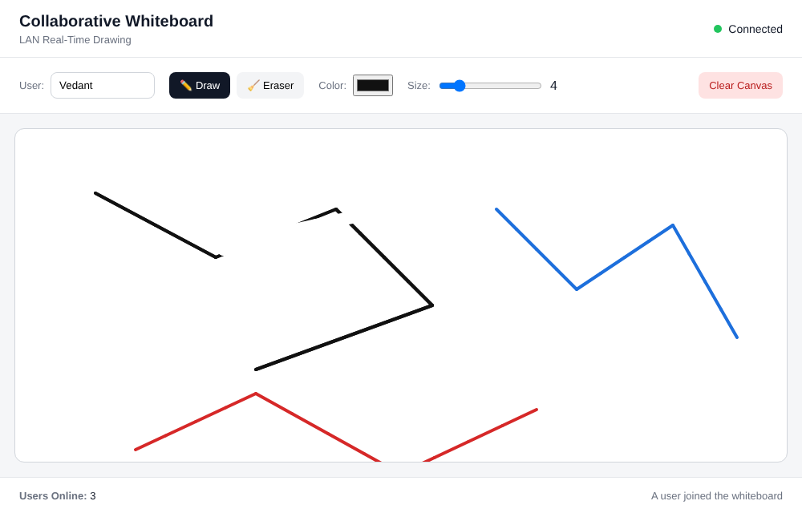  Figure 4.5 Erase by Client B is reflected on Client A | 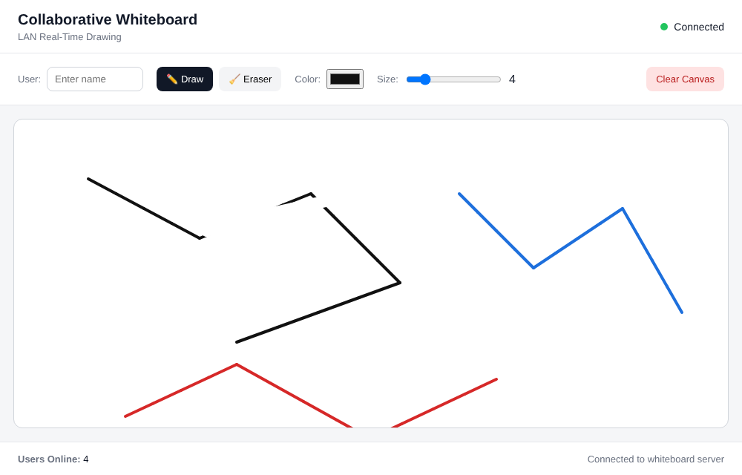  Figure 4.6 A late joiner receives the existing drawing

Figure 4.7 (test T7) shows the user count returning to 3 after one client closed its page, which confirms that the server detects the disconnection and broadcasts USER_LEFT. Figure 4.8 (test T5) shows every canvas empty after CLEAR.
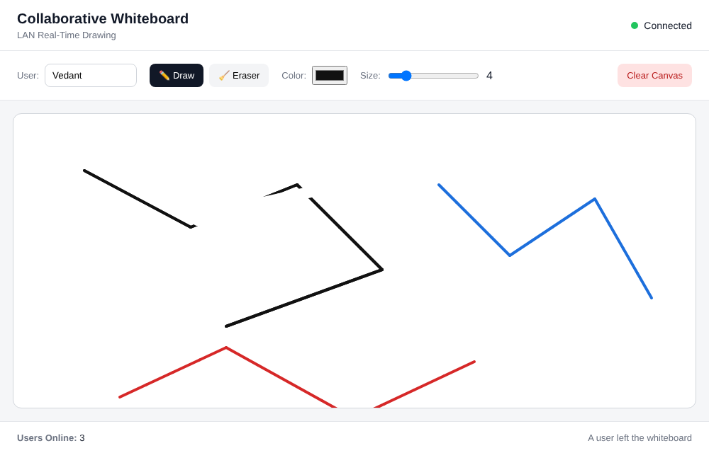  Figure 4.7 After one client closes, the count returns to 3 | 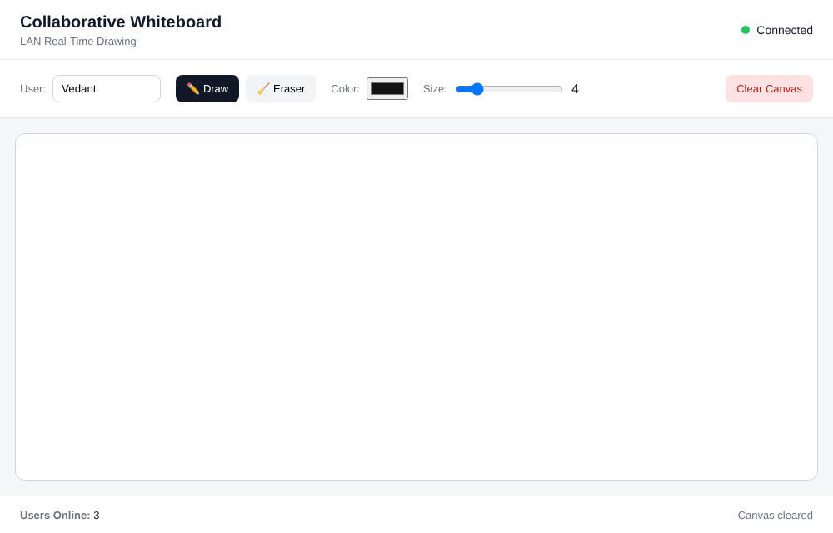  Figure 4.8 After CLEAR every canvas is empty

4.2.1 Performance Measurements
Performance was measured with a script that opens raw WebSocket connections to the running server on the loopback interface. Delivery delay is the time from sending a DRAW message from one client until the same message is received by a second client. Because Wi-Fi delay is not included, these values are lower bounds; they show that the server itself adds very little delay.
Table 4.2 Performance measurements (loopback, n = 200 unless stated)
Metric | How it was measured | Value
Connected clients | Clients connected at the same time during the load test | 12 simultaneous WebSocket clients
PING → PONG round trip | 200 PING messages; time until PONG returns | Mean 0.17 ms, median 0.16 ms, max 1.4 ms
Delivery delay (A → server → B) | 200 DRAW messages from client A; time until client B receives it | Mean 0.21 ms, median 0.20 ms, max 0.55 ms
Broadcast load | One client sends 500 DRAW events; 9 other clients count what they receive | 500 of 500 received by each receiver (4,500 deliveries) in 0.11 s
Observed issues | Lost events, stalls, disconnections | No lost events; a malformed JSON message closed only that client’s connection

4.3 Objective Achievement
Table 4.3 connects each objective to its test evidence. Because all tests ran on one machine through the loopback interface, the outcomes for network-dependent objectives are reported with that condition.
Table 4.3 Objective achievement
Objective ID | Evidence or Test ID | Outcome
O1 | T1, T2; Figures 4.1, 4.2 | Achieved (several browser clients; tested on one host)
O2 | T3, T4, T5; Figures 4.3–4.5, 4.8 | Achieved
O3 | T1–T3, Figure 3.2; delay measurements | Achieved (delay measured on loopback only)
O4 | T3–T6 | Achieved
O5 | T6, T7, T8; Figures 4.6, 4.7 | Achieved
O6 | T1–T9, Table 4.2 | Achieved on loopback; re-measurement on a physical Wi-Fi LAN remains

5 Discussion and Conclusion

5.1 Discussion and Comparative Analysis
All nine tests passed, and no events were lost in the broadcast test. The mean delivery delay of 0.21 ms and the PING–PONG round trip of 0.17 ms show that the server’s own processing adds very little delay. These are lower bounds, because the loopback interface has no Wi-Fi medium access, contention or interference; the real delay on a physical LAN must be re-measured.
Table 5.1 compares the design choices made in this project with the common alternatives, using the criteria discussed in Chapters 2 and 3.
Table 5.1 Design choices compared with alternatives
Design decision | Alternative | Chosen approach | Reason
Live update transport | Repeated HTTP polling | WebSocket over one TCP connection | One handshake, then small frames pushed at once; no repeated requests and headers
Connection topology | Peer-to-peer, up to N(N−1)/2 connections | Central server, N connections | Simple clients, one place for the drawing history; but a single point of failure
Data sent | Screenshots of the board | JSON drawing events (about 130–200 bytes) | Far smaller messages; each browser renders at its own resolution; history can be replayed

The project also connects classroom topics to an observable application. The team can explain the difference between a host IP address and a port; why 0.0.0.0 is a bind address and not a destination; how HTTP and WebSocket differ and why WebSocket starts as an HTTP request; how TCP gives reliable ordered delivery to the application; how a server tracks and broadcasts to many clients; and what happens at the application level when a client disconnects or the server restarts.

5.2 Advantages and Applications
- Clients need only a web browser; nothing is installed on client devices.
- The system works inside a LAN without an Internet connection.
- Messages are small, so little bandwidth is needed compared with sending images.
- Late joiners and reconnecting clients automatically receive the current drawing.
- The application demonstrates HTTP, WebSocket, TCP, IP addressing and client–server communication in one working system.
Relevant applications include shared diagramming in classrooms and laboratories, group problem solving on topologies and calculations, small meeting rooms, and teaching or demonstrating how application-layer protocols run over TCP/IP.

5.3 Limitations
- The server is a single point of failure; if it stops, live collaboration stops.
- The drawing is kept in memory only: it is lost on restart, and canvas_operations grows without limit during a long session because every segment, including erase segments, is stored and replayed to late joiners.
- There are no user accounts, roles, private rooms or persistent storage.
- The eraser works by painting wider white segments rather than removing earlier operations, and the server echoes each event back to its sender, so the sender redraws its own segments.
- Performance depends on Wi-Fi quality, device load, event frequency and the number of clients; the figures in this report were measured on a loopback connection.
- Access fails on networks with client isolation or restrictive firewalls.

5.3.1 Security Considerations
- The development version is intended for a trusted demonstration network, not for exposure to the public Internet.
- There is no authentication or room separation: anyone who can reach the host and port can connect, see the board and clear it.
- The server does not validate numeric fields or limit message size and rate. Malformed JSON ends only the offending client’s connection, but oversized or very frequent messages are not restricted.
- Traffic uses unencrypted ws:// over http://. Encrypted transport (HTTPS/WSS), origin checks and authorisation should be added before wider deployment.
- The user name typed in the toolbar is sent by the client but is not used or stored by the server.
- A host firewall may need a narrowly scoped rule for the selected port; avoid disabling the firewall entirely, and stop the server after the demonstration.

5.4 Challenges and Troubleshooting
Table 5.2 lists the technical issues met or anticipated during testing, their cause and the correction. Items marked “observed” were verified in the tests of Chapter 4; the others are precautions based on how the network behaves.
Table 5.2 Challenges and troubleshooting
Issue | Cause or Diagnosis | Solution and Verification
Malformed (non-JSON) message sent to the server (observed) | The receive loop cannot parse the message and raises an exception | The handler removes only that client and broadcasts USER_LEFT; verified that all other clients continued normally
Board is empty after the server restarts (observed) | Drawing is held only in memory (canvas_operations) | Clients retry every 2 s and reconnect; verified in T8 that a new client receives an empty SYNC. Persistent storage is future work
Connection dropped by a closed tab or lost Wi-Fi (observed) | The server must not keep sending to a dead socket | WebSocketDisconnect and failed sends remove the client; verified in T7 by the count dropping from 4 to 3
Browser cannot open the page when 0.0.0.0 is typed as the address | 0.0.0.0 is only a bind address, not a destination | Use the host’s LAN IP address, or http://localhost:8000 on the host itself
Clients cannot reach the host on some Wi-Fi networks (precaution) | Guest Wi-Fi, client (AP) isolation or firewall rules block traffic to the host | Use a network without client isolation and a narrowly scoped firewall rule for TCP port 8000

5.5 Future Scope
- Add shared rooms, access codes and user names displayed beside each cursor or stroke.
- Store drawing events persistently so a session can be restored after a restart, and compact the history.
- Add undo/redo using an event history or command model, and a true eraser that removes operations.
- Batch or throttle pointer events, and exclude the sender when broadcasting, to reduce messages.
- Show reconnection status and recover missed events after temporary network loss.
- Measure latency and message volume on a real Wi-Fi LAN with repeatable conditions, and inspect the traffic with Wireshark.
- Add automated tests for malformed input, large drawings and many concurrent users.

5.6 Conclusion
The LAN-Based Collaborative Whiteboard shows how network protocols combine to deliver a useful multi-user application. A browser loads the interface over HTTP, upgrades to a persistent WebSocket connection carried by TCP, and exchanges small JSON messages with a central FastAPI server, which stores the drawing, broadcasts every action to all clients and replays the board to anyone who joins. Joins, leaves, clearing, erasing and automatic reconnection are all handled.
The prototype was tested with up to twelve simultaneous clients: all nine test cases passed, all 500 events of the load test reached every receiver, and the server stayed responsive when a malformed message arrived. All six objectives were met on the loopback test setup. The main limitations are that state is held only in memory, there is no authentication or encryption, and the tests were run on a loopback connection; these are the first points to improve and to re-test on a physical LAN.

References
[1] W. Eddy, Ed., “Transmission Control Protocol (TCP),” RFC 9293, Internet Engineering Task Force, Aug. 2022. [Online]. Available: https://www.rfc-editor.org/rfc/rfc9293
[2] R. Fielding, M. Nottingham, and J. Reschke, Eds., “HTTP Semantics,” RFC 9110, Internet Engineering Task Force, Jun. 2022. [Online]. Available: https://www.rfc-editor.org/rfc/rfc9110
[3] I. Fette and A. Melnikov, “The WebSocket Protocol,” RFC 6455, Internet Engineering Task Force, Dec. 2011. [Online]. Available: https://www.rfc-editor.org/rfc/rfc6455
[4] FastAPI, “WebSockets,” FastAPI Documentation. [Online]. Available: https://fastapi.tiangolo.com/advanced/websockets/
[5] Uvicorn, “Uvicorn: An ASGI web server for Python.” [Online]. Available: https://www.uvicorn.org/
[6] MDN Web Docs, “WebSocket API,” Mozilla. [Online]. Available: https://developer.mozilla.org/en-US/docs/Web/API/WebSocket
[7] MDN Web Docs, “Canvas API,” Mozilla. [Online]. Available: https://developer.mozilla.org/en-US/docs/Web/API/Canvas_API
[8] Python Software Foundation, “Socket Programming HOWTO,” Python 3 Documentation. [Online]. Available: https://docs.python.org/3/howto/sockets.html
[9] Project implementation files: server/main.py, server/requirements.txt, client/index.html, client/style.css, client/app.js and README.md, LAN-Collaborative-Whiteboard project, 2026.

AI Usage Declaration
We used ChatGpt , Claude
Declaration: We take responsibility for the accuracy of this report and understand the submitted implementation and results. Sources and assistance used have been acknowledged.
Student Name | PRN | Signature
Vedant Pawaskar | 1262242102
Prajakta Choughule | 1262241465
Yashraj Agale | 1262242073
Bhavya Maisuria | 1262243418

Appendices

Appendix A Code and Configuration
The complete source code is part of the project submission. Table A.1 identifies the files and modules; the start command is uvicorn main:app --host 0.0.0.0 --port 8000.
Table A.1 Project files and modules
File | Module / role | Description
server/main.py | FastAPI application | HTTP routes (/, /static, /status), the /ws endpoint, connected_clients, canvas_operations and broadcast()
server/requirements.txt | Dependencies | fastapi and uvicorn[standard]
client/index.html | Page | Toolbar and canvas markup
client/style.css | Styling | Layout and appearance of the page
client/app.js | Client logic | Pointer capture, JSON events, rendering, WebSocket connection and automatic reconnect
START_WINDOWS.bat / START_MAC_LINUX.sh | Start scripts | Create a virtual environment, install requirements and start Uvicorn

Appendix B Additional Evidence
Table B.1 maps the course syllabus units to the places where they appear in this project.
Table B.1 Mapping of the syllabus to the project
Syllabus unit | Topics covered | Where it appears in this project
Unit I – Fundamentals | LAN, network architectures and topologies, transmission media, OSI and TCP/IP models, Ethernet | Star-topology Wi-Fi/Ethernet LAN; layered protocol stack (Table 2.4); client–server architecture
Unit II – Data Link Layer | Multiple access protocols (CSMA/CD, CSMA/CA), Ethernet frame format | Wi-Fi/Ethernet link that carries the traffic; Wi-Fi medium access uses CSMA/CA (provided by the network hardware, not by the application)
Unit III – Network Layer | IPv4 addressing, subnetting, NAT, ARP, ICMP | Host and clients on one private IPv4 subnet; host LAN IP used in the URL; 0.0.0.0 bind address; ARP/ICMP operate underneath
Unit IV – Transport Layer | Sockets, UDP, TCP services and connection, congestion control | WebSocket over a TCP connection to port 8000; TCP reliability and ordering; socket-based client–server communication
Unit V – Application Layer | HTTP, FTP, SMTP, DNS, SNMP | HTTP delivers the page; WebSocket is the application-layer protocol for live updates; JSON as the data format; /status endpoint exposes server information

Appendix C Individual Contributions
Table C.1 records the contribution of each student to design, implementation, testing, report preparation and presentation.
Table C.1 Individual contributions

Member | Contribution | Evidence / task completed
Vedant Pawaskar (1262242102) | Backend development: FastAPI server, WebSocket endpoint, broadcast logic | server/main.py: /ws endpoint, broadcast(), connected_clients, canvas_operations, SYNC/WELCOME/USER_JOINED/USER_LEFT handling
Prajakta Chougule (1262241465) | Frontend development: canvas drawing, toolbar, UI | client/index.html, client/style.css, client/app.js: pointer events, colour picker, brush size, eraser, Clear button, connection status
Yashraj Agale  (1262242073) | Documentation and setup: report, README, start scripts, diagrams, references | This report, README.md, START_WINDOWS.bat, START_MAC_LINUX.sh, architecture and sequence diagrams (Figures 1–2)
Bhavya Maisuria (1262243418) | Testing and performance: test cases, multi-device LAN testing, latency measurement | Test table T1–T9 (Section 7.2), screenshots (Section 7.3), PING/PONG latency results (Section 8.5), Wireshark capture if you do it

